Box Cricket League 30th -31st January 2021
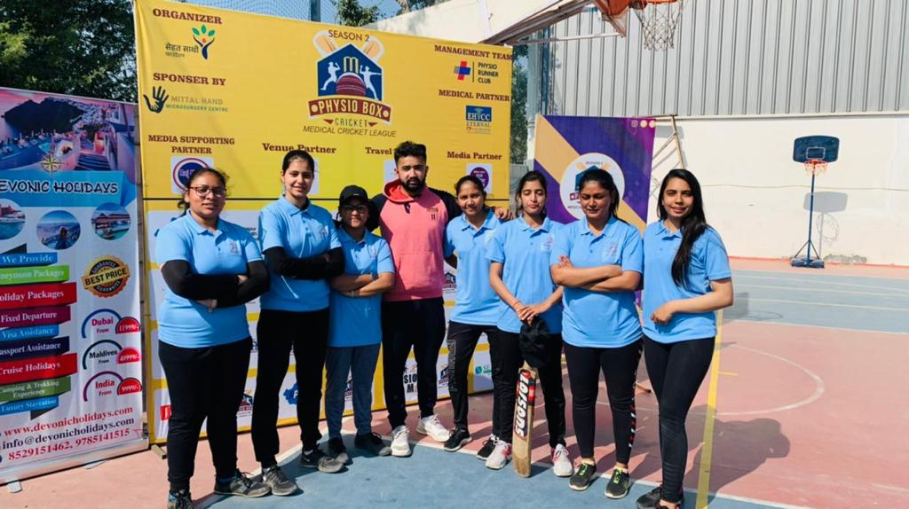
BPT Students of MGPC with Alumni Dr. Utkarsh Kulshreshtha (BPT Batch 2015) Team Rehabit
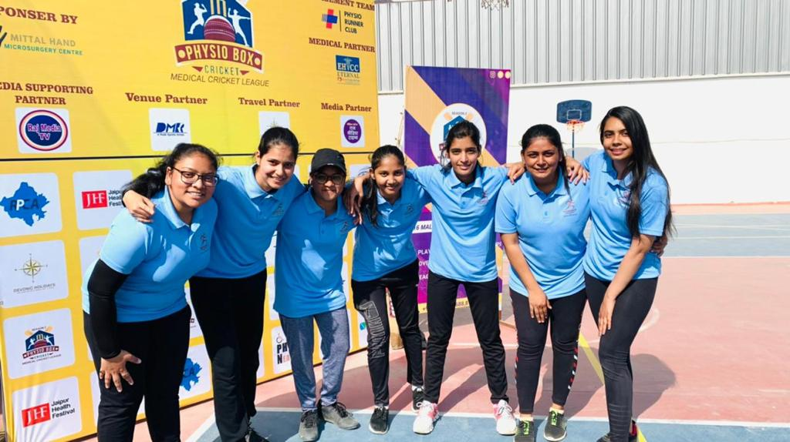

Box Cricket League 30th -31st January 2021
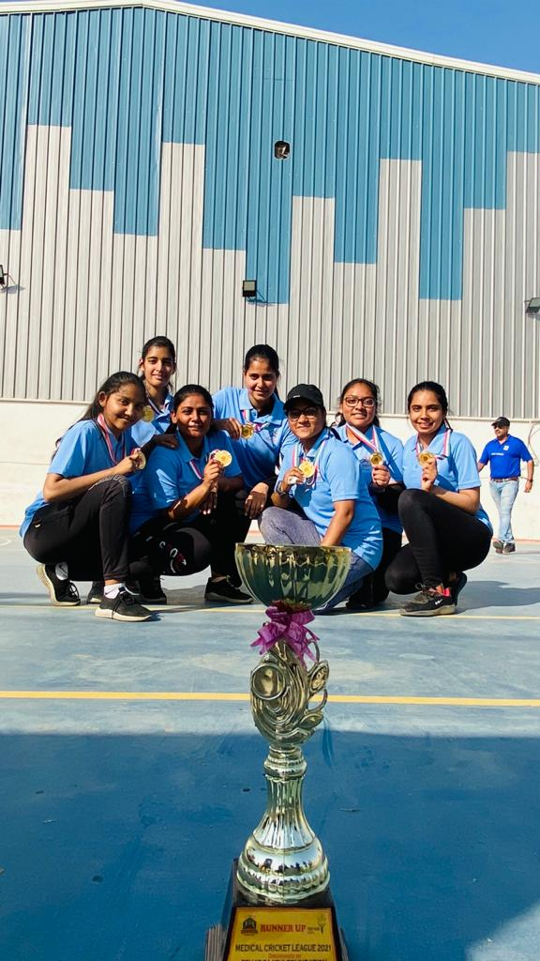

Box Cricket League 30th -31st January 2021
